AIS5281 — AI for Science
Research Report
Deep Learning-Assisted Parameter Inversion for a Light-Driven DNA Molecular Motor
A Proof-of-Concept Study on Closed-Loop Inverse Characterization from Three-Channel Fluorescence Kinetics

Tse Kam Pui (A0330028U)
Supervisor: Prof. Wang Zhisong
Co-supervisor: Prof. Duane Loh
Institution: National University of Singapore — Faculty of Science
Date: 2026/4/19

Abstract
This study examines an inverse characterization problem for a light-driven DNA molecular motor operating on a three-site track. The goal is to infer seven microscopic physical parameters from three experimentally observable fluorescence kinetics curves (FAM, TYE, and CY5). A finite-state mechanical-kinetic forward simulator — originally a MATLAB model and re-implemented here as a bit-aligned, vectorized pure-Python simulator (pysim) that reproduces the MATLAB output while running about 35× faster — was used to generate 30,000 synthetic training samples. Two inverse models were then trained on these synthetic data: a 1D convolutional neural network (1D-CNN) and a PatchTST-inspired Transformer with explicit multi-head temporal and cross-channel attention. At inference, the deep-learning prediction is used as a warm start for a model-agnostic physics-refinement step (Powell with multi-start) that minimizes curve RMSE directly through the forward simulator.
Evaluation was performed at three levels. First, model selection used a 1,000-sample held-out synthetic test set scored by curve-reconstruction RMSE (predicted parameters → forward simulation → RMSE against the sample's own curve). The CNN was uniformly stronger than the Transformer (mean curve RMSE 0.0188 vs. 0.0465; catastrophic-failure rate 0.1% vs. 3.2%). A five-seed retraining study confirmed the gap is statistically robust and not a single-run artifact: CNN 0.0196±0.0007 vs. Transformer 0.0395±0.0036, with non-overlapping ranges. Second, a synthetic parameter-recovery experiment and a Fisher-information / profile-likelihood analysis quantified parameter identifiability. Third, a closed-loop verification on the experimental fluorescence record regenerated trajectories through the original simulator; after physics refinement the CNN reached a channel-averaged RMSE of 0.0078 on the original trace and 0.0161 on a generalization trace, both better than the published reference fit.
These results show that synthetic-data-trained neural models, combined with physics refinement, can drive closed-loop parameter inversion for this DNA motor system. The study also makes the problem's limits explicit and quantitative: the inverse map is intrinsically ill-posed (Fisher-information condition number ≈ 1.3×10¹⁵) and the non-identifiability is parameter-dependent, so the inferred parameters are best interpreted as closed-loop-consistent candidates rather than uniquely recovered ground truth. The experimental validation, while strengthened by a generalization trace, remains limited in scope.

1. Introduction

1a. Broader Context and Literature Review
DNA nanotechnology has enabled the construction of increasingly sophisticated nanoscale systems by exploiting the programmability of Watson-Crick base pairing[1]. Within this broader field, light-responsive DNA structures are of particular interest because optical inputs can modulate molecular interactions without introducing additional chemical waste into the reaction environment[2][3]. Light-driven DNA molecular motors are a representative example: their operation couples sequence-programmed hybridization with photoresponsive elements, allowing motion to be regulated by alternating visible and UV illumination.
The system studied here is a light-driven DNA walker moving on a three-site track. Its operation can be understood in terms of a mechanically and kinetically coupled energy landscape in which azobenzene-modified hairpin fuels alter binding preferences under different illumination conditions[8]. Experimentally, the resulting motion is monitored through three fluorescence channels, FAM, TYE, and CY5, which provide indirect readouts of the walker's configuration over time.
Figure 1 provides a schematic overview of the motor architecture, the three-site track, the fluorescence reporters, and the light-switching mechanism that underlies the measured kinetics.
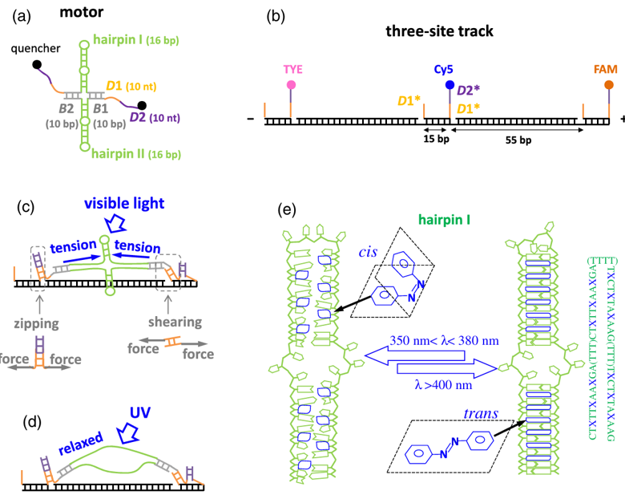
Figure 1. Schematic of the light-driven DNA molecular motor studied in this work. The figure shows the motor structure, the three-site track, the placement of the FAM, TYE, and CY5 fluorescence reporters, and the visible-light / UV switching mechanism mediated by azobenzene-containing hairpin fuel elements.
This schematic is important for the inverse problem because the experimental observables are not the microscopic state occupancies themselves, but fluorescence readouts produced by the underlying motor-track dynamics. The learning task therefore seeks to infer latent physical parameters from indirect multichannel kinetic signatures rather than from direct state measurements.
A central challenge in this system is the inverse problem: given experimentally measured fluorescence kinetics curves, can one infer the underlying microscopic physical parameters that produced the observed behavior? Traditional analysis has relied heavily on manual or optimization-based fitting of simulated trajectories to experimental curves. Such approaches can be time-consuming and can become unstable when multiple parameter combinations produce similar fluorescence patterns.
More broadly, inverse problems in physical and biological systems are often affected by non-convex loss landscapes and practical identifiability limitations[4][7]. Recent machine-learning studies have shown that neural networks can be useful for inverse problems involving spectroscopic or mechanistic observables[5][6][7]. However, to the best of our knowledge, deep-learning-based parameter inversion has not been systematically examined for the specific DNA walker system studied here.

1b. Competing Hypotheses
Several scientific and methodological questions motivate this work. On the physical side, it is not obvious whether the observed kinetics are more strongly shaped by energetic terms, such as state free-energy differences, or by kinetic terms, such as migration and force-dependent dissociation rates[8]. On the inference side, it is unclear whether three macroscopic fluorescence trajectories contain enough information to constrain seven microscopic parameters in a practically useful way, especially when multiple parameter sets may generate near-similar curves.
These considerations suggest two competing possibilities. A favorable scenario is that subtle multichannel temporal structure contains enough information for a learned inverse model to recover parameter sets that are at least operationally useful in closed-loop verification. A less favorable scenario is that sim-to-real mismatch and parameter degeneracy dominate, in which case a neural inverse map may fit synthetic data well but fail to regenerate experimental traces through the original simulator. The present study is designed to distinguish between these possibilities at a proof-of-concept level.

1c. Specific AI for Science Problem
The AI-for-Science task considered here is a multivariate regression problem: infer seven physical parameters from three synchronized fluorescence kinetics curves measured over a 130-minute experiment.
The input is therefore a three-channel time series with 7,801 time points per channel, and the output is a seven-dimensional parameter vector comprising three binding-energy terms, one migration rate, one zero-force dissociation rate, and two force-coupling distances.
This formulation is challenging because the forward map from parameters to fluorescence curves is nonlinear, the parameters span different physical scales, and the inverse map may be non-unique in practice. For this reason, the paper emphasizes closed-loop consistency rather than claiming that the inferred parameters are uniquely correct in a strict physical sense.

1d. Approach and Motivation
To explore this inverse problem, we train two neural predictors on synthetic trajectories generated by a pure-Python forward simulator (pysim, a vectorized re-implementation of the original MATLAB model): a 1D-CNN and a PatchTST-inspired Transformer with multi-head attention[12]. Both models take the three fluorescence curves as input and output seven normalized physical parameters. At inference, the deep-learning prediction is not used as the final answer but as a warm start for a model-agnostic physics-refinement step that minimizes curve RMSE directly through the forward simulator.
Physics refinement (Powell with multi-start) is the key inference-time component: because the inverse map is ill-posed, a parameter prediction with small parameter error need not reproduce the observed curves, so the prediction is refined in curve space against the original simulator. Final closed-loop verification is always performed with this same simulator. The main questions are therefore which architecture provides the more accurate and reliable prediction, and how much the deep-learning warm start reduces the physical-simulation cost of refinement relative to uninformed initial guesses.

2. Data Provenance

2a. Data Collection and Instrumentation
The training data used in this study are synthetic and were generated with a finite-state mechanical-kinetic forward simulator derived from a previously reported model of the light-driven DNA walker system[8]. The simulator was originally written in MATLAB (`gendata.m`) and has been re-implemented here as a bit-aligned, vectorized pure-Python module (`pysim.py`) that reproduces the MATLAB trajectories while running roughly 35× faster; the Python implementation is used for all data generation and closed-loop verification in this work, with the MATLAB scripts retained as legacy references. The simulated motor operates on a three-site track and is represented by a 14-dimensional probability vector over physically accessible motor-track configurations. The model alternates between visible-light and UV-light conditions, which modify the azobenzene-dependent hairpin energetics and thereby alter the transition kinetics between states.
The finite-state representation used by the simulator is summarized in Figure 2.
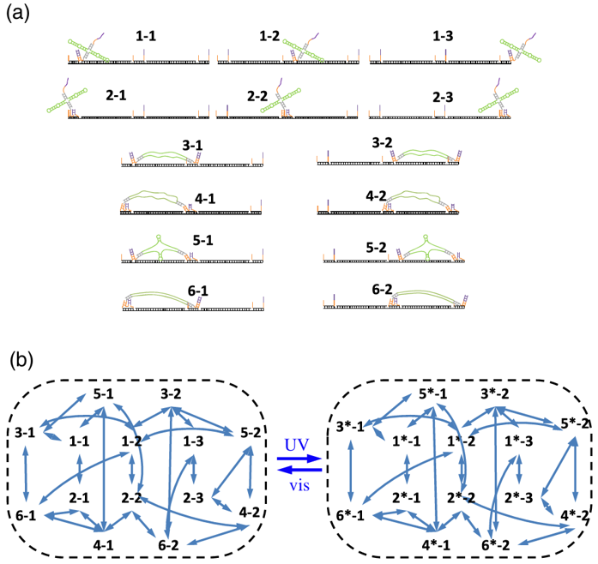
Figure 2. Finite-state representation of the light-driven DNA walker used in the forward model. The figure summarizes the 14 accessible motor-track states and the illumination-dependent transition network under visible-light and UV conditions.
Within the simulator, each state corresponds to a physically accessible motor-track configuration. The forward model can be summarized in two coupled parts: a mechanical free-energy module that assigns an energy to each accessible state, and a kinetic module that governs how illumination-dependent transition rates redistribute state probability over time. The resulting state occupancies are then converted into the three fluorescence signals used for learning and closed-loop verification.
For clarity, the core relations underlying the simulator are summarized below. Following Hou et al.[8], the mechanical component represents the free energy of each motor-track configuration as the sum of an entropic stretching term, a hairpin-opening term, and a leg-track binding term:
$$E=F_{t}+E_{h}+E_{b}$$
$$F_{t}=2k_{B}T\left(l_{eff}/l_{p}\right){\left(z_{eff}/l_{eff}\right)}^{2}\left(3-2z_{eff}/l_{eff}\right)/\left[4\left(1-z_{eff}/l_{eff}\right)\right]$$
$$f=2k_{B}T/l_{p}\left[z_{eff}/l_{eff}+1/4{\left(1-z_{eff}/l_{eff}\right)}^{2}-1/4\right]$$
$$l_{eff}=2n_{open}l_{c-nt},z_{eff}=\left(n_{tr-leg}-n_{w-bp}\right)l_{c-bp}$$
$$E_{h}=-n_{open}E_{hp-op},E_{hp-op}=E_{hp-UV} or E_{hp-vis}$$
$$E_{b}=n_{leg-bp}E_{bp}$$
Within this formulation, free-energy minimization over each configuration determines quantities such as the number of bound leg base pairs, opened leg nucleotides, and opened hairpin bases. In the simulator, these relations define the illumination-dependent energy landscape of the 14-state system and provide the state energies that are subsequently passed to the kinetic transition model[8].
Using this energy landscape, the forward simulation proceeds as follows. Given seven inferred parameters together with 19 fixed structural, mechanical, and signal-model constants (see Table 1), the model computes configuration free energies under visible and UV conditions, constructs illumination-specific transition matrices, integrates the master equation for the state-probability vector, and finally converts the evolving state occupancies into three fluorescence signals (FAM, TYE, and CY5). Each simulation spans 130 minutes at 1-second resolution, yielding 7,801 time points per channel. The Python implementation compresses the per-second sub-stepping into one matrix multiply per second via matrix powers, giving the ~35× speed-up without changing the numerical result.
Table 1. Fixed structural, mechanical, and signal-model constants used in the forward simulator
Category | Symbol | Physical meaning | Value | Unit / note
Structural | n_D1 | Length of domain D1 | 10 | nt
Structural | n_D2 | Length of domain D2 | 10 | nt
Structural | n_S1 | Length of spacer S1 | 4 | nt
Structural | n_gray | Gray linker segment length | 10 | bp
Structural | n_hairpin_1 | Stem length of hairpin I | 8 | bp
Structural | n_hairpin_2 | Stem length of hairpin II | 8 | bp
Structural | n_azo_1 | Azobenzene count in hairpin I | 3 | units
Structural | n_azo_2 | Azobenzene count in hairpin II | 3 | units
Structural | n_T_hairpin_1 | Toehold length adjacent to hairpin I | 3 | nt
Structural | n_T_hairpin_2 | Toehold length adjacent to hairpin II | 2 | nt
Structural | n_track_1 | Track spacing between sites 1 and 2 | 15 | bp
Structural | n_track_2 | Track spacing between sites 2 and 3 | 55 | bp
Mechanical | kBT | Thermal energy scale | 4.14 | pN·nm
Mechanical | lp_s | Persistence length of ssDNA | 0.75 | nm
Mechanical | lc_s | Contour length per nucleotide | 0.70 | nm / nt
Mechanical | lc_d | Contour length per base pair | 0.34 | nm / bp
Mechanical | di_DNA | Effective DNA diameter | 2 | nm
Signal-model | dE_TYE | Fixed TYE-channel energy offset | -1.55 | model constant
Signal-model | p_unbind_track | Fixed CY5 background contribution | 0.09507 | dimensionless
The constants listed in Table 1 are fixed across the generated dataset, whereas the seven inferred parameters are sampled and predicted by the inverse models.
The time evolution of the state vector is modeled with a time-dependent master-equation formalism[8], which is the form used in the present trajectory simulator:
$$dp_{i}/dt={\text{Σ}}_{\text{j}}\left(p_{j}k_{j},i-p_{i}k_{i},j\right)$$
$$k_{j},i=k_{i},jexp\left(-ΔE_{i},j/k_{B}T\right),ΔE_{i},j=E_{i}-E_{j}$$
$$k_{d}=k_{0}e^{\left(fδ/k_{B}T\right)},k_{mig}=k_{-}mige^{\left(-\text{Δ}E_{2,1}/k_{B}T\right)}$$
In the current implementation, the force-coupling term is represented by the direction-dependent parameters `drt_z` and `drt_s`, while the visible/UV switching schedule is taken from the experimental protocol. Hou et al. discuss both time-dependent and steady-state viewpoints; the present work uses the time-dependent form because the learning target is the full fluorescence trajectory[8]. Taken together, the mechanical and kinetic relations above define the forward operator that links latent parameter values to observable fluorescence kinetics. This same forward operator is used twice in the present study: first to generate synthetic trajectories for training, and then to assess predicted parameters through closed-loop regeneration against experiment.
Parameter sampling was performed with Latin Hypercube Sampling to cover the seven-dimensional parameter space. The sampled parameter ranges follow the current project configuration: E_b in [−2.0, −0.5] k_BT, E_b_azo_trans in [−2.0, −0.5] k_BT, E_b_azo_cis in [−0.5, 0.2] k_BT, k_mig in [0.01, 0.30] s⁻¹, k₀ in [10⁻⁷, 10⁻⁴] s⁻¹, drt_z in [0.20, 0.90] nm, and drt_s in [0.01, 0.50] nm. Simulations were parallelized in MATLAB using `parfor`.
Figure 3 shows the marginal distributions of the seven target parameters in the initial candidate set generated by Latin Hypercube Sampling. At this stage, the objective is not yet dataset curation, but stratified one-dimensional coverage of the admissible range of each parameter before validity screening and activity-based acceptance are applied.
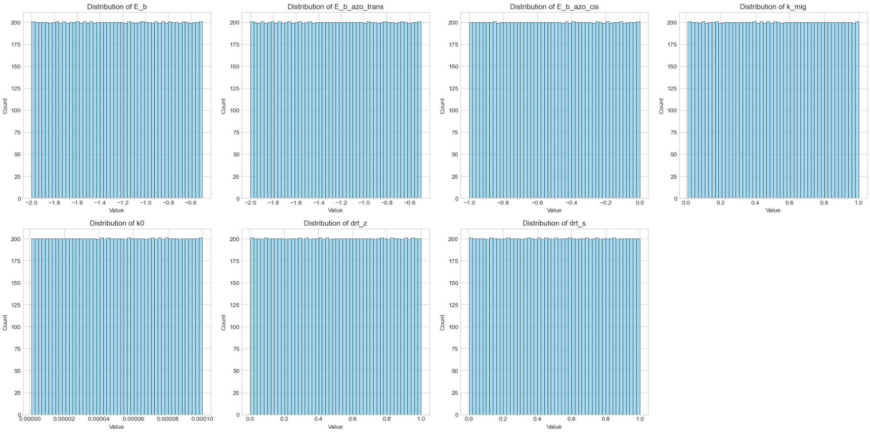
Figure 3. Marginal distributions of the seven physical parameters in the initial candidate set generated by Latin Hypercube Sampling. The nearly equal bin counts reflect the stratified marginal coverage provided by the LHS design.
The near-uniform bin counts are consistent with the intended behavior of the LHS design. This pre-filter distribution should therefore be interpreted as the sampling prior used to explore parameter space, rather than as the composition of the final retained dataset.
The experimental data used for closed-loop verification were read from `Fig3a_fitting.xlsx`. This file contains one three-channel fluorescence record over the same nominal 130-minute time window. These experimental curves were not used for model training. Instead, they were reserved for post-training closed-loop evaluation in which predicted parameters were passed back to the original (pysim) simulator and the regenerated trajectories were compared with the measured curves.
The physical model and corresponding equations used in this work follow the finite-state mechanical-kinetic formulation reported by Hou et al.[8].

2b. Pre-processing and Data Characteristics
The synthetic-data pipeline included several filtering and preprocessing steps. Parameter combinations requiring extremely small time steps were excluded for computational feasibility. Simulations producing invalid values or negligible kinetic variation were removed. To reduce activity-level imbalance, accepted samples were binned by maximum signal variation and retained using a quota-based acceptance strategy until 30,000 valid samples had been collected.
Figure 4 presents representative examples of the generated input trajectories X. Each panel corresponds to one randomly selected retained sample and contains the three synchronized fluorescence channels used as input to the inverse models.
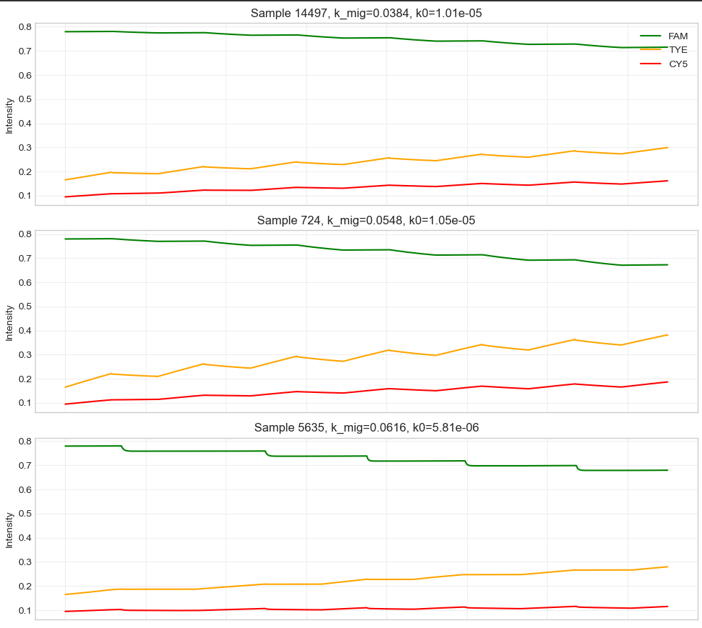
Figure 4. Representative synthetic fluorescence trajectories from three randomly selected training samples. Each sample contains the three synchronized channels (FAM, TYE, and CY5) generated by the MATLAB forward model.
Although these examples are not intended as a statistical summary of the full training set, they clarify the form of the learning input and illustrate that the retained synthetic trajectories preserve diverse multi-channel temporal patterns while remaining consistent with the mechanistic constraints of the forward model.
Preprocessing then proceeded as follows. The dissociation-rate parameter k₀ was log-transformed because of its broad numerical range. Extreme numerical outliers were removed. For both inverse models, each sample's three fluorescence curves were jointly z-score normalized so that cross-channel amplitude relationships were preserved while sample-specific offsets were reduced.
Targets were scaled to the interval [0.1, 0.9] before training, and the dataset was then divided into training, validation, and test splits using the current project configuration.
Figure 5 shows the marginal distributions of the retained parameter labels Y after quality-control filtering and activity-based acceptance sampling. Unlike the idealized pre-filter case in Figure 3, exact uniformity is no longer expected because retention is constrained simultaneously by simulation validity, signal quality, and dataset-balance requirements.
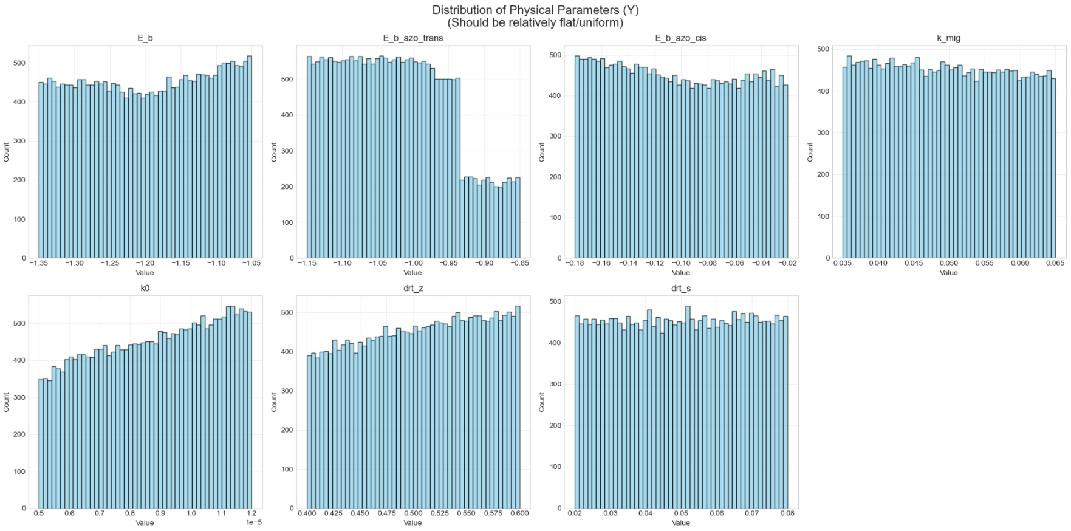
Figure 5. Marginal distributions of the seven physical parameters in the final retained dataset after quality-control filtering and activity-based acceptance sampling.
The final marginals are therefore only approximately balanced rather than perfectly flat. In the context of the present dataset, this is a desirable outcome: the acceptance procedure preserves broad coverage of the parameter space while excluding large numbers of uninformative or numerically problematic samples.

2c. Data Limitations and Constraints
Several limitations of the data should be made explicit. First, the training distribution is entirely simulator-generated, so model performance is necessarily conditioned on the assumptions built into the forward model. Real experimental traces may contain effects such as photobleaching, fluorophore crosstalk, instrumental drift, or unmodeled conformational heterogeneity that are not represented in the synthetic dataset.
Second, the inverse problem is not fully identifiable, and this study quantifies that explicitly. A synthetic recovery experiment (200 Latin-Hypercube ground-truth samples passed through the full predict-and-refine pipeline) shows that only three kinetic/duty-ratio parameters (drt_z, k0, drt_s) are moderately recoverable (R² ≈ 0.42–0.55), while the binding energies and the migration rate are poorly constrained (R² ≤ 0.15, negative for k_mig). A Fisher-information analysis gives a condition number of ≈ 1.3×10¹⁵ with eigenvalues spanning ~15 orders of magnitude, confirming a near-singular, parameter-dependent identifiability structure. Closed-loop agreement is therefore treated as evidence of curve-space consistency, not as proof of unique physical recovery.
Third, the experimental evaluation, although strengthened relative to a single-trace check, remains limited. Closed-loop verification uses two three-channel fluorescence records (an original trace and a generalization trace); this supports a feasibility and preliminary-generalization claim but is still insufficient for a strong claim of broad sim-to-real robustness. Additional experimental traces, perturbation conditions, and repeated measurements would be needed for a more rigorous validation.

3. Model Design and Architecture

3a. Model Choice and Motivation
We compare two inverse models for the same parameter-regression task: a 1D convolutional neural network (InverseCNN) and a patch-based Transformer with multi-head attention (DNAWalkerTransformer). Both take the three-channel fluorescence time series as input and output the seven-parameter vector. The CNN is the production model in this study; the Transformer is included as a strong, higher-inductive-flexibility baseline. A central empirical question is whether a global, attention-based receptive field actually helps on these smooth, cycle-dominated fluorescence curves, or whether the CNN's local-to-global convolutional bias is the better match — a question Section 4 answers decisively in favor of the CNN.
Architecture 1: InverseCNN (1D Convolutional Neural Network). The InverseCNN is a four-layer 1D-CNN designed specifically for regression from temporal signals to physical parameters. The architecture consists of a convolutional feature extractor followed by a fully connected regression head, following the general paradigm of convolution-based hierarchical representation learning[9][10]. In the design rationale, the first convolutional layer uses a relatively large kernel size of 21 time points (approximately 21 s) to capture the fundamental temporal scale associated with the 10-minute light cycling period, while the subsequent layers adopt smaller kernels (5, 5, and 3) to progressively compose higher-order temporal features[10]. Batch normalization is applied after each convolutional layer to improve training stability, and an adaptive average pooling layer is used at the final stage to produce a fixed-size feature map regardless of input length, thereby increasing architectural flexibility. In addition, relatively low dropout rates are adopted (0.05 in the convolutional blocks and 0.10 in the fully connected layers), since regression tasks are generally more sensitive to information loss than classification tasks.
Feature Extractor:
• Layer 1: Conv1d(3→32, kernel=21, stride=2, padding=10) + BatchNorm + ReLU + MaxPool(2) + Dropout(0.05)
• Layer 2: Conv1d(32→64, kernel=5, stride=2, padding=2) + BatchNorm + ReLU + MaxPool(2) + Dropout(0.05)
• Layer 3: Conv1d(64→128, kernel=5, stride=2, padding=2) + BatchNorm + ReLU + MaxPool(2) + Dropout(0.05)
• Layer 4: Conv1d(128→256, kernel=3, stride=2, padding=1) + BatchNorm + ReLU + AdaptiveAvgPool1d(64)
Regression Head:
• Flatten → Linear(256×64→256) + ReLU + Dropout(0.10)
• Linear(256→128) + ReLU + Dropout(0.10)
• Linear(128→7) + Sigmoid
Design rationale: the first convolutional layer uses a large kernel (21 time points ≈ 21 s) to capture the fundamental scale of the 10-minute light-cycling period, and subsequent layers (kernels 5, 5, 3) compose higher-order temporal features; BatchNorm stabilizes training and AdaptiveAvgPool1d(64) fixes the feature-map size. Dropout is kept low (0.05 conv, 0.10 FC) because regression is more sensitive to information loss than classification. The key inductive-bias argument is that the observable curves are smooth and dominated by the periodic illumination schedule, with the diagnostic information carried by local waveform shape and amplitude rather than by long-range token interactions; a convolutional hierarchy that builds progressively larger receptive fields is therefore well matched to this signal class, and with 4.38M parameters the CNN also has ample capacity. Sections 4c and 4f show this bias — not raw capacity — is what makes the CNN both more accurate and more reliable here.
Architecture 2: DNAWalkerTransformer (PatchTST-inspired, multi-head attention). As a higher-flexibility baseline, the Transformer targets two CNN limitations — a bounded receptive field and only implicit inter-channel coupling — using a patch-based representation[12] with explicit multi-head self-attention[11] applied first along the temporal (patch) axis within each channel and then across the three channels.
Architecture (patch = stride = 100): per-channel Conv1d patch embedding + LayerNorm → learnable positional encoding → temporal multi-head-attention blocks (with GELU FFNs) → cross-channel multi-head-attention blocks → global average pooling over patches and channels → LayerNorm → Linear(d_model/2) + GELU + Dropout → Linear → 7 + Sigmoid. The model has ~3.24M parameters and trains at ~23 s/epoch on Apple-Silicon MPS.
Design rationale: explicit attention provides a global temporal and cross-channel receptive field that the CNN can only approximate. Whether this added flexibility actually helps on these smooth curves is treated as an empirical question; the answer (Section 4) is that it does not — the extra flexibility instead increases the rate of occasional non-physical predictions.
Design rationale: a patch-based representation lets the model process the long fluorescence trajectories while retaining local temporal context, and explicit multi-head attention provides a global receptive field along time and across channels. The two attention stages (temporal then cross-channel) are intended to capture exactly the long-range and inter-channel structure the CNN can only model implicitly. Whether this added capacity actually helps on these smooth curves is treated as an empirical question, answered in Section 4.
Inference-time component: physics refinement. Rather than a neural forward surrogate, the production pipeline pairs each inverse model with a model-agnostic physics-refinement step (`refine.py`). The deep-learning prediction is used as a warm-start initial guess for a local optimizer (Powell with multi-start) that minimizes the channel-averaged curve RMSE evaluated directly by the original forward simulator (in log10 space for the wide-range parameter k0). Because refinement operates in curve space through the true simulator, it corrects the ill-posedness that leaves curve fit and parameter error only loosely coupled, and it is identical for both architectures — so model quality is judged by the pre-refinement prediction, while refinement delivers the final physical parameters.

3b. Training Methodology
1D-CNN (InverseCNN) Training:
The CNN is trained using an adaptive weighted MSE loss function. Initially, all 7 parameters are assigned equal weight (w_i = 1.0). After each validation epoch, per-parameter MSE values are computed, and the weights are updated using an exponential moving average (EMA) scheme:
$$raw_{w}eights_{i}=\sqrt{\left(MSE_{i}+{10}^{-6}\right)} \\ normalized_{w}eights=raw_{w}eights/mean\left(raw_{w}eights\right) \\ param_{w}eights=0.9×param_{w}eights+0.1×normalized_{w}eights$$This adaptive weighting ensures balanced learning across all parameters—when the model struggles with a particular parameter (high MSE), its weight is automatically increased, directing more gradient signal toward improving that parameter. The √(·) operator provides a moderate rather than aggressive correction, and the EMA smoothing (α = 0.1) prevents oscillatory weight updates.
Training details:
• Optimizer: Adam (lr = 5 × 10⁻⁴)
• Scheduler: ReduceLROnPlateau (mode=min, factor=0.5, patience=30, min_lr=10⁻⁶)
• Batch size: 256
• Max epochs: 2,000 (with early stopping patience = 200)
• Gradient clipping: max_norm = 1.0
• Hardware: NVIDIA GPU via HPC cluster
Transformer (DNAWalkerTransformer) Training:
The Transformer is trained end-to-end as a direct curves→parameters regressor, using the same per-sample joint-channel z-score input normalization and [0.1, 0.9] target scaling as the CNN; no neural forward decoder or multi-phase encoder-decoder scheme is used.
Training details:
• Loss: MSE on the seven normalized parameters (Safe-Sigmoid output lock to [0.1, 0.9]).
• Optimizer: AdamW (weight decay = 10⁻⁴).
• Scheduler: cosine annealing with linear warmup.
• Architecture: PatchTST-style patch embedding (patch = stride = 100) + multi-head temporal attention + cross-channel attention.
• Max epochs: 300 (early stopping). ~23 s/epoch on Apple-Silicon MPS.
The y_scaler is fitted exclusively on the training split (not the entire dataset) to prevent label leakage — a common pitfall in regression pipelines.$$L=α×MSE\left(X,\hat{X}\right)+β×Σwᵢ{\left(Yᵢ-Ŷᵢ\right)}^{2}$$

3c. Training Results and Model Evaluation
The 1D-CNN model was trained on 30,000 synthetic samples (24,000 training, 3,000 validation, 3,000 test) for approximately 2,000 epochs with early stopping. The model converged to a validation MSE on the order of 10⁻³ in the normalized [0.1, 0.9] parameter space. These training results indicate that the CNN can learn a useful inverse map on simulator-generated data, although synthetic-data performance alone is not sufficient to establish real-data validity.
Key observations from the CNN training:
• The adaptive loss weighting successfully balanced learning across all 7 parameters, preventing the model from overfitting to easy parameters (e.g., E_b) while neglecting harder ones (e.g., k₀, drt_s).
• The learning rate scheduler triggered multiple decay events, typically around epochs 200–400 and 600–800, correlating with learning plateaus.
• Per-parameter test MSE analysis revealed that energy parameters (E_b, E_b_azo_trans) are predicted with higher accuracy than kinetic/mechanical parameters (k₀, drt_s), consistent with the expectation that binding energies have a more direct and monotonic influence on the observable fluorescence curves.
• The Sigmoid output activation effectively prevented out-of-range predictions, ensuring all predicted parameters remain physically plausible.
The Transformer was trained end-to-end with multi-head temporal and cross-channel attention (patch = 100). It converges to competitive parameter-prediction loss on synthetic data, but — as quantified in Section 4 — its curve-reconstruction quality on the held-out test set is markedly worse and less stable than the CNN's, with a much higher rate of catastrophic (non-physical) predictions.
With the forward simulator, the two inverse architectures, and the physics-refinement step in place, the remaining questions are (i) which architecture predicts more accurately and reliably on held-out data, (ii) whether those predictions remain useful when refined and returned to the simulator on real experimental traces, and (iii) how much the deep-learning warm start reduces the simulation cost of refinement. The evaluation in Section 4 addresses these in turn.

4. Results

4a. Closed-loop evaluation on experimental data
Building on the forward model and training pipeline above, the evaluation proceeds at three levels: (i) model selection on a 1,000-sample held-out synthetic test set scored by curve-reconstruction RMSE, with a five-seed retraining study for statistical robustness; (ii) identifiability analysis (synthetic recovery, Fisher information, profile likelihood) and a warm-start ablation that quantifies the value of the deep-learning prediction; and (iii) closed-loop verification on experimental fluorescence records, in which predicted-and-refined parameters are returned to the original simulator and the regenerated trajectories are compared with the measured FAM, TYE, and CY5 signals.
Model selection is based on the held-out synthetic test set, where the ground-truth parameters are known: each model predicts parameters, the prediction is forward-simulated, and the curve RMSE against the sample's own curve is recorded (no refinement, so the metric reflects prediction quality alone). On 1,000 samples the CNN achieves a mean curve RMSE of 0.0188 (median 0.0096, P90 0.047) with a 0.1% catastrophic-failure rate, whereas the Transformer achieves 0.0465 (median 0.0153, P90 0.117) with a 3.2% failure rate. A five-seed retraining study confirms the gap is robust rather than a lucky seed: CNN 0.0196±0.0007 (CV 3.5%) vs. Transformer 0.0395±0.0036 (CV 9.1%), with non-overlapping ranges across the two models. The CNN is therefore selected as the production model, and is both more accurate and more stable than the Transformer on this task.

4b. Closed-loop comparison of baseline, CNN, and Transformer results
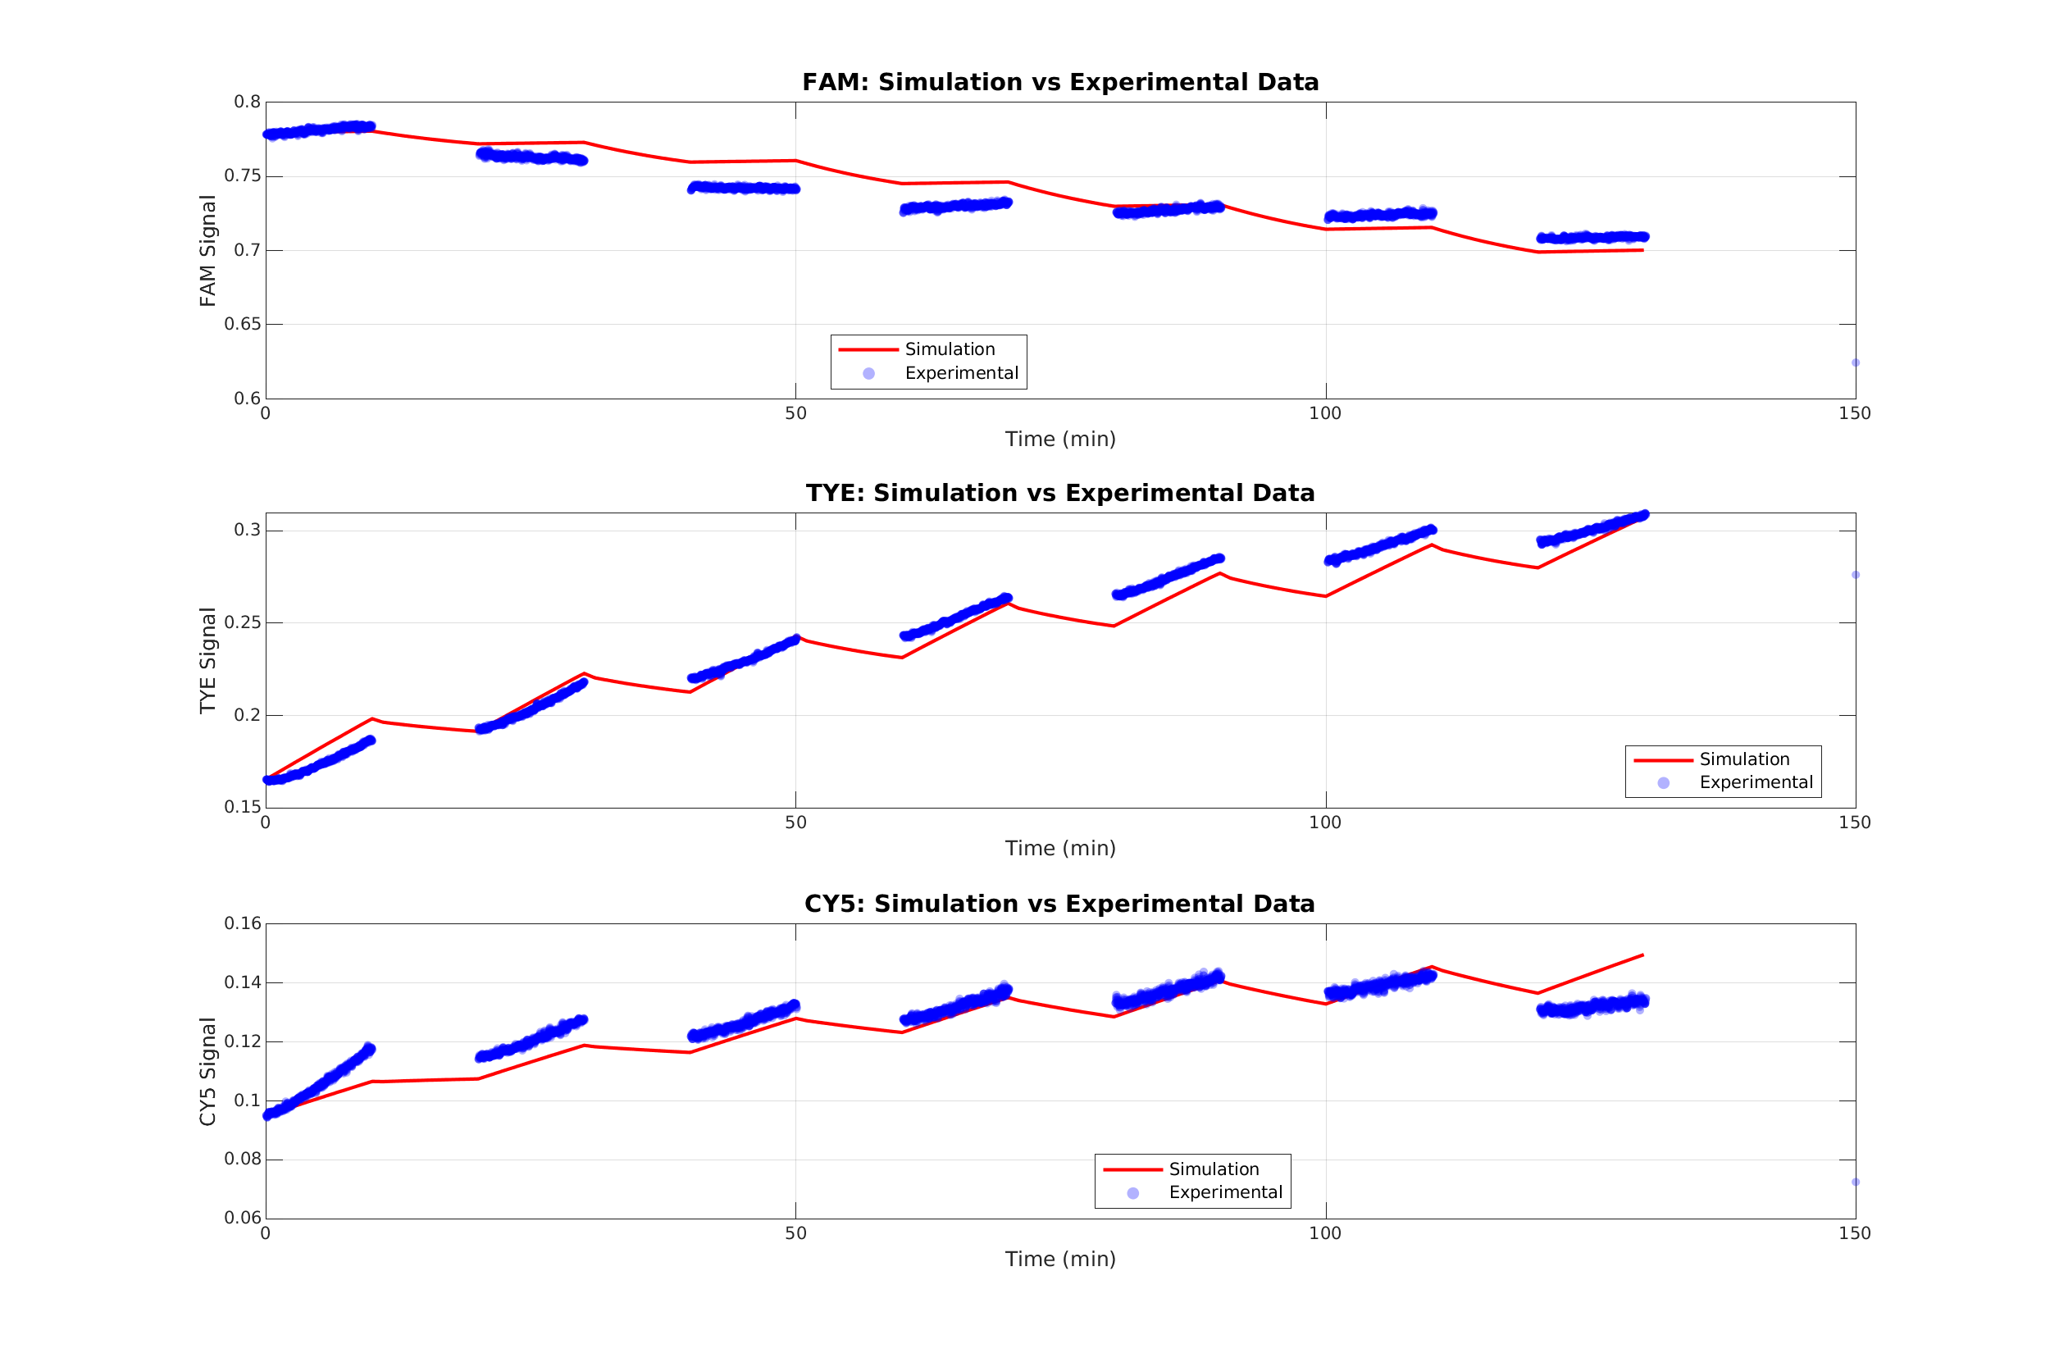
Figure 6. Closed-loop comparison between the baseline simulation generated from the reference parameter set and the experimental fluorescence data before learning-based inversion.
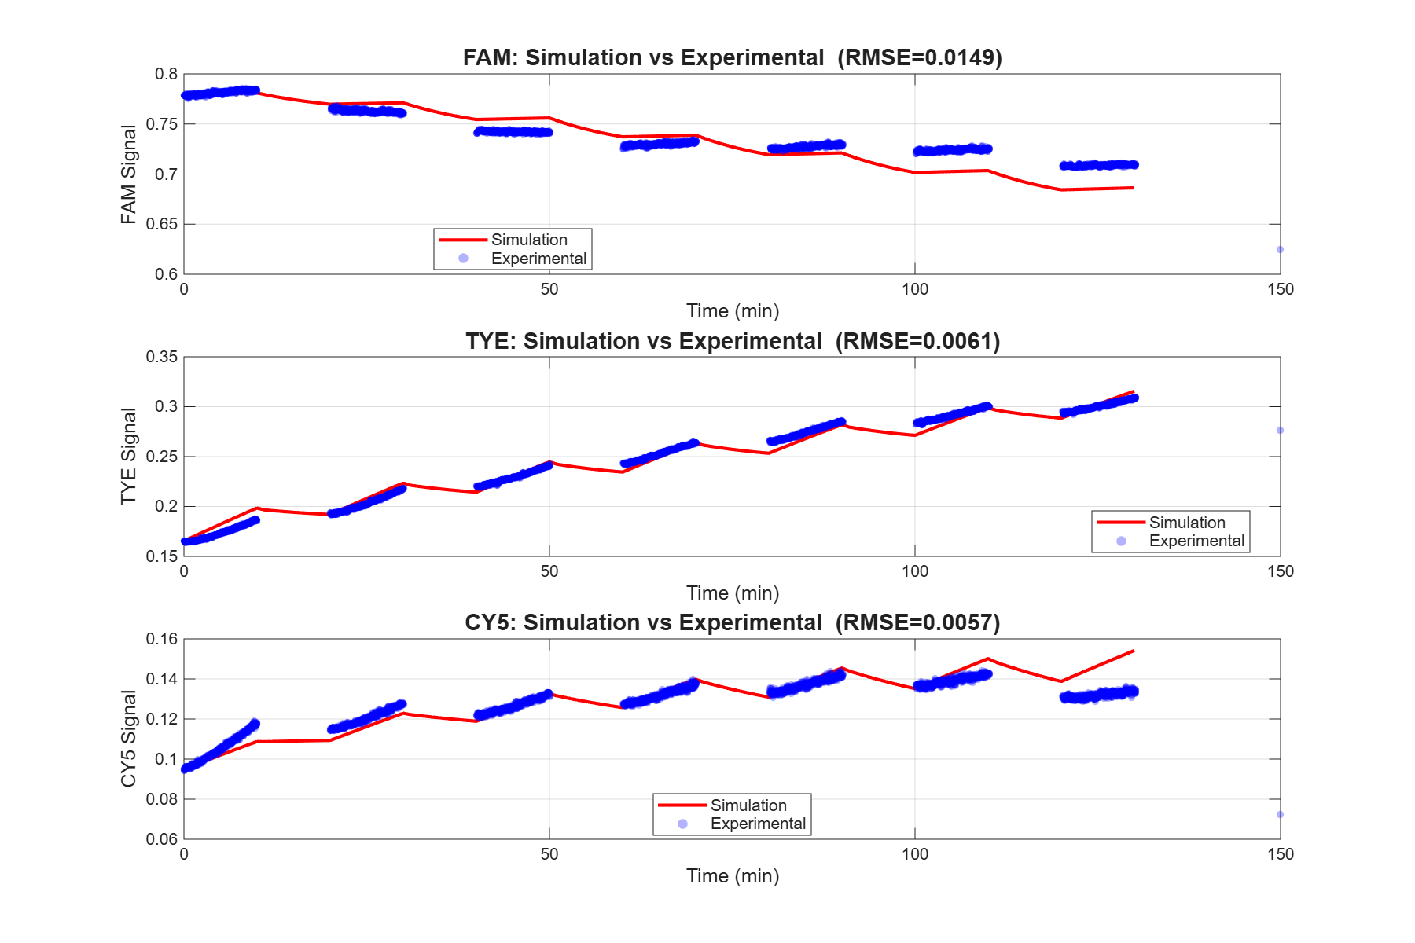
Figure 7. Closed-loop verification for the best-performing CNN configuration on the tested experimental trace.
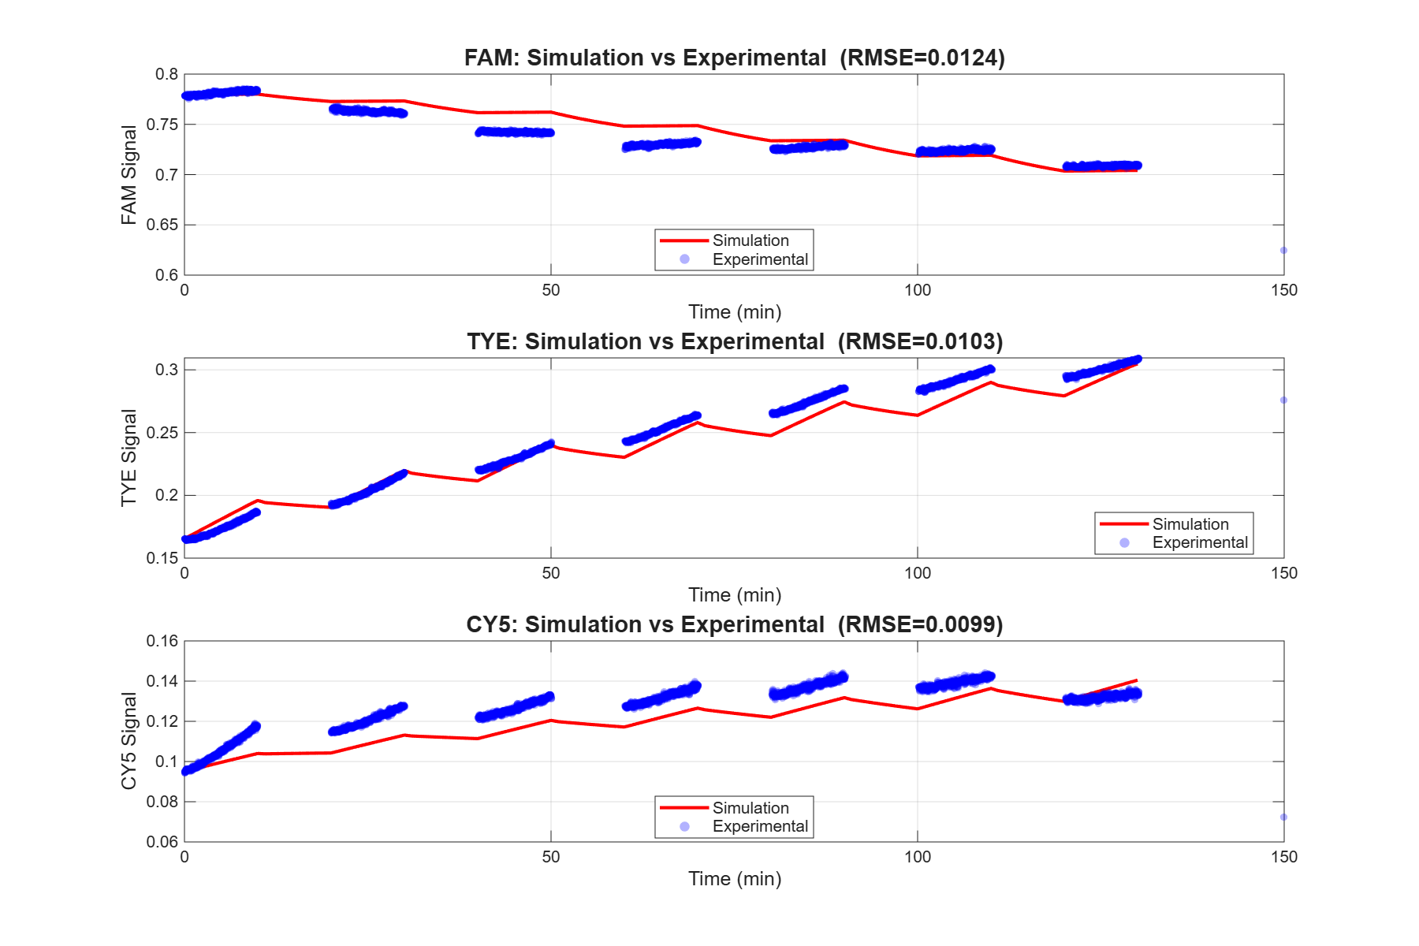
Figure 8. Closed-loop verification for the best-performing Transformer configuration on the tested experimental trace.
Figures 6-8 summarize the closed-loop experimental verification, in which the selected model's prediction is refined against the original simulator and the regenerated trajectories are compared with the measured curves.
Figure 6 shows the baseline simulation generated from the reference parameter set before learning-based inversion. The baseline reproduces the coarse trend of the three channels, confirming that the forward model captures the overall operating principle of the system, but visible mismatches in channel amplitude and local temporal shape remain over repeated illumination cycles (channel-averaged RMSE of the reference fit ≈ 0.0089 on the original trace, as reported in the source study).
Figure 7 shows the CNN-based closed-loop result with physics refinement. On the original experimental trace the regenerated curves reach channel-wise RMSE of 0.0122 (FAM), 0.0046 (TYE), and 0.0066 (CY5), for a channel-averaged RMSE of 0.0078 — better than the reference fit (≈ 0.0089). On an independent generalization trace the CNN reaches a channel-averaged RMSE of 0.0161, compared with ≈ 0.0338 for the reference baseline on that trace, i.e. roughly a 2× improvement.
Figure 8 shows the Transformer-based closed-loop result. After the same physics refinement it reaches a comparable channel-averaged RMSE (≈ 0.0080 original, 0.0170 generalization), because refinement is model-agnostic and pulls both predictions toward the same physical lower bound in curve space. This is exactly why the model comparison is made on the pre-refinement test-set metric (Section 4a), where the CNN is clearly superior; refinement is used only to deliver the best final physical parameters, not to rank architectures.
Figure 8b consolidates the CNN closed-loop fit on both experimental traces. On the original trace the refined channel-wise RMSE is 0.0122 (FAM), 0.0046 (TYE), and 0.0066 (CY5), averaging 0.0078; on the independent generalization trace it is 0.0228, 0.0098, and 0.0156, averaging 0.0161. Both averages beat the reference fit (≈0.0089 and ≈0.0338, respectively), and the per-channel balance shows the model does not improve one channel at the expense of another.
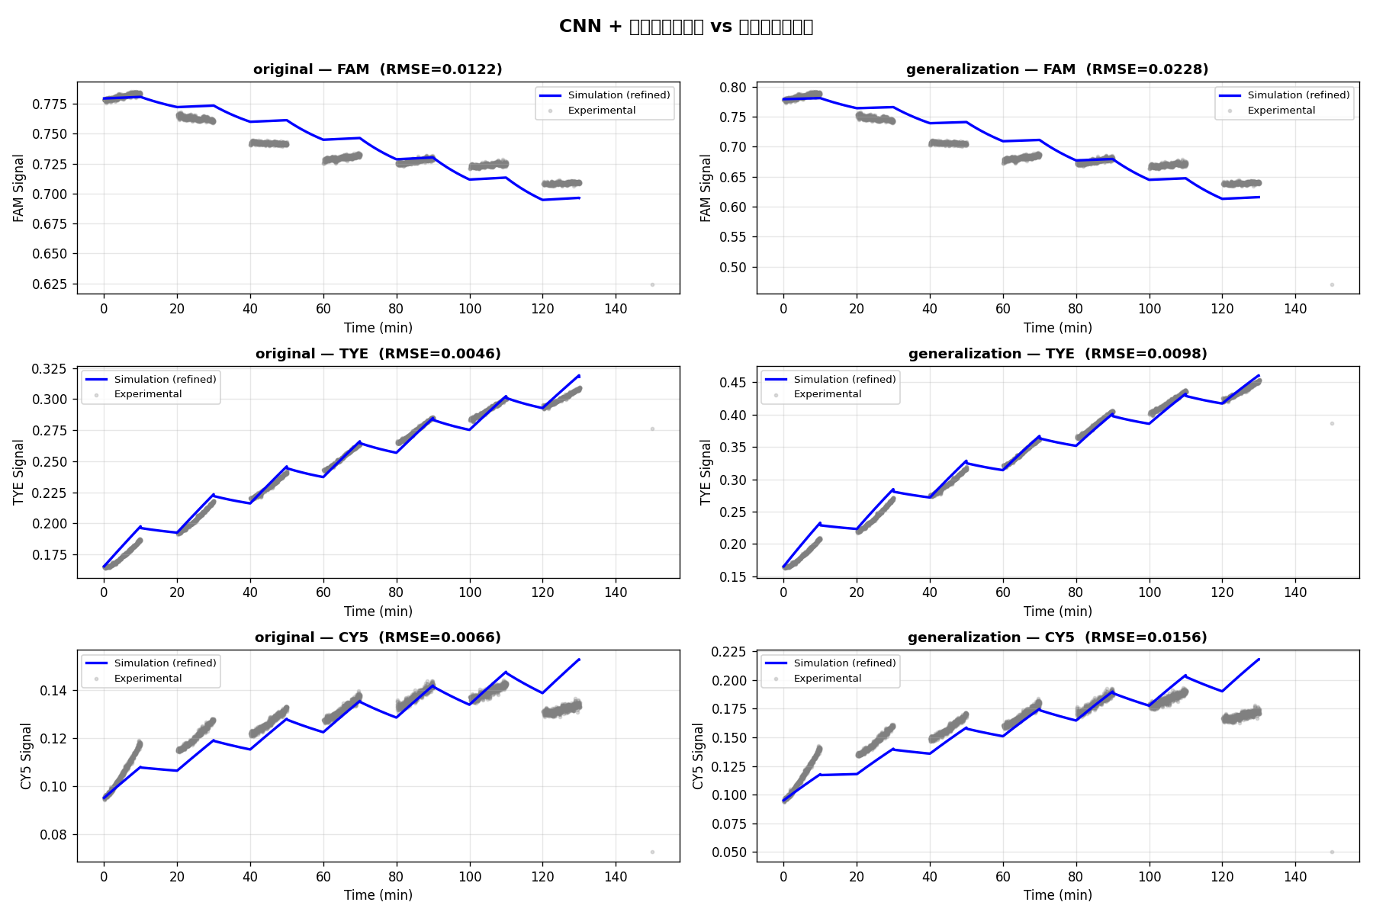
Figure 8b. CNN closed-loop fit with physics refinement on both experimental traces (top row: original; bottom row: generalization; columns: FAM, TYE, CY5). Blue curves are the refined forward simulation; gray points are the measured fluorescence. Channel-averaged RMSE is 0.0078 (original) and 0.0161 (generalization), both better than the reference parameter fit.

4c. Quantitative comparison between CNN and Transformer
Model | Mean curve RMSE | Median | P90 | Catastrophic-failure rate | 5-seed mean ± std
1D-CNN (selected) | 0.0188 | 0.0096 | 0.047 | 0.1% | 0.0196 ± 0.0007
Transformer | 0.0465 | 0.0153 | 0.117 | 3.2% | 0.0395 ± 0.0036
The model comparison is summarized in Table 2 by pre-refinement curve-reconstruction RMSE on the 1,000-sample held-out test set (the metric used for model selection), alongside the five-seed mean±std. The CNN is uniformly stronger — lower mean and median curve RMSE, a far lower catastrophic-failure rate, and a lower five-seed mean with a smaller coefficient of variation. After model-agnostic physics refinement, both models converge to a similar closed-loop fit on the experimental traces (CNN 0.0078 / Transformer 0.0080 on the original trace), so refinement is reported as the delivery step rather than as the basis for the architecture ranking.

4d. Results summary
Taken together, the results support three conclusions. First, on held-out synthetic data the CNN is the more accurate and more stable inverse model, and a five-seed study shows this advantage is statistically robust (non-overlapping ranges). Second, deep-learning prediction is valuable as a warm start: in an ablation over 50 target curves, the CNN initial guess reaches the target curve RMSE with a median of 1 forward-simulation call (the prediction already meets the target for most curves), versus 96 (random), 141 (reference), and 185 (Latin-Hypercube multi-start), cutting the simulation budget for equal-quality refinement by roughly two orders of magnitude. Third, on the experimental fluorescence records the predicted-and-refined parameters regenerate trajectories that are closer to the measurements than the reference parameter set on both the original and the generalization traces.
What the results do not show is equally important and is now quantified rather than merely asserted. The inverse map is intrinsically ill-posed (Fisher-information condition number ≈ 1.3×10¹⁵) and the non-identifiability is parameter-dependent, so the inferred parameters are not uniquely recovered ground truth. The experimental validation, while extended to a generalization trace, still spans only two records and does not establish broad sim-to-real robustness, and the study does not yet provide full posterior uncertainty quantification.

4e. Identifiability, warm-start value, and statistical robustness
Beyond model selection and closed-loop fitting, three computation-only experiments characterize the inverse problem itself and the contribution of the deep-learning predictor. All three use the forward simulator as a source of known-truth synthetic data and report platform-independent metrics.
Parameter identifiability. A synthetic recovery experiment (200 Latin-Hypercube ground-truth samples through the full predict-and-refine pipeline) shows a parameter-dependent recovery structure: drt_z (R² = 0.55), k0 (0.52), and drt_s (0.42) are moderately recoverable, whereas E_b (0.15), E_b_azo_trans (0.10), E_b_azo_cis (−0.09), and k_mig (−0.68) are poorly constrained. A Fisher-information analysis at the reference parameters gives a condition number of ≈ 1.3×10¹⁵ with eigenvalues spanning ~15 orders of magnitude, and a profile-likelihood scan independently confirms that k0 has the sharpest RMSE valley (most identifiable) while E_b_azo_trans and drt_s are nearly flat. The three methods agree, establishing a near-singular, parameter-dependent identifiability structure and explaining why curve-space physics refinement is indispensable. Figure 9 summarizes the per-parameter curve sensitivity.
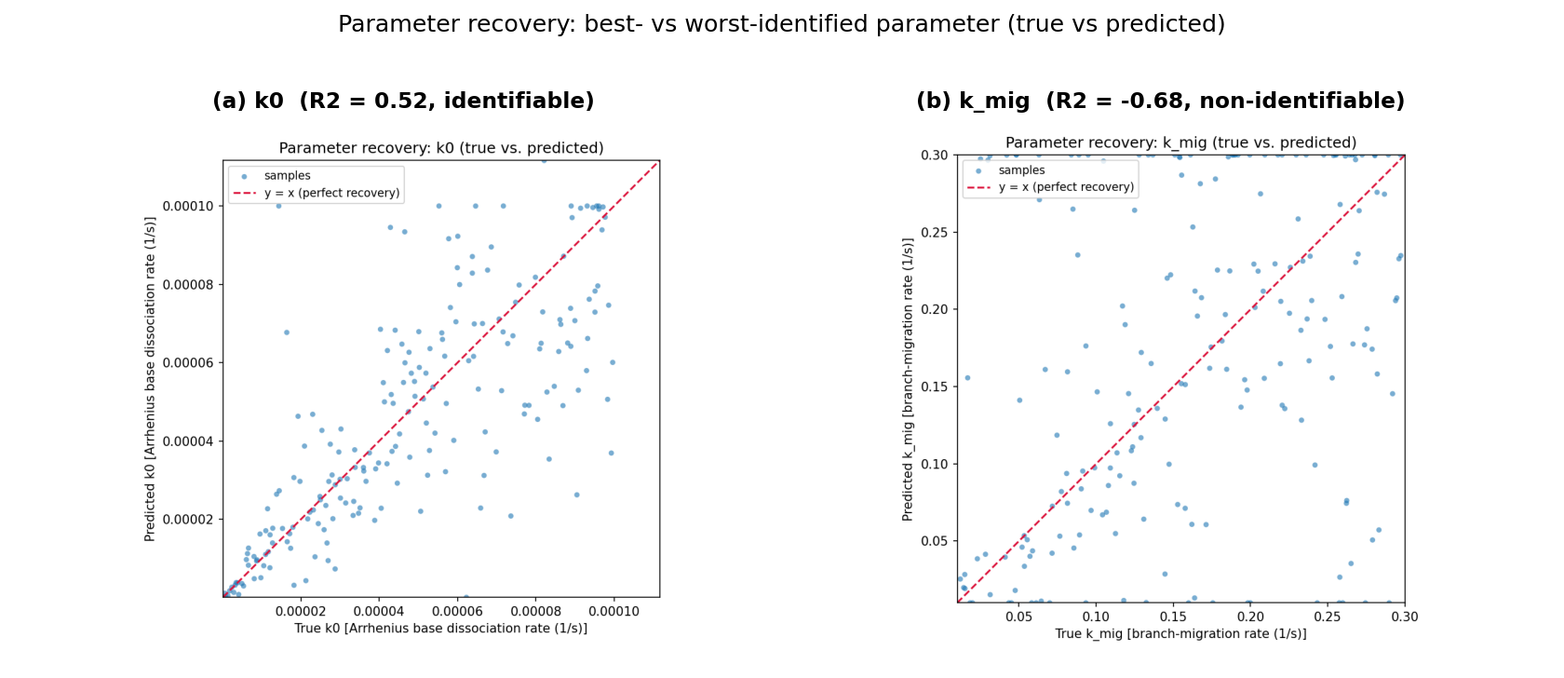
Figure 8c. True-vs-predicted recovery scatter for the best- and worst-identified parameters from the 200-sample synthetic recovery experiment. k0 (left, R² = 0.52) is recovered along the y = x line, whereas k_mig (right, R² = −0.68) is essentially unconstrained — predictions cluster without tracking the truth — illustrating the parameter-dependent non-identifiability of the inverse problem.
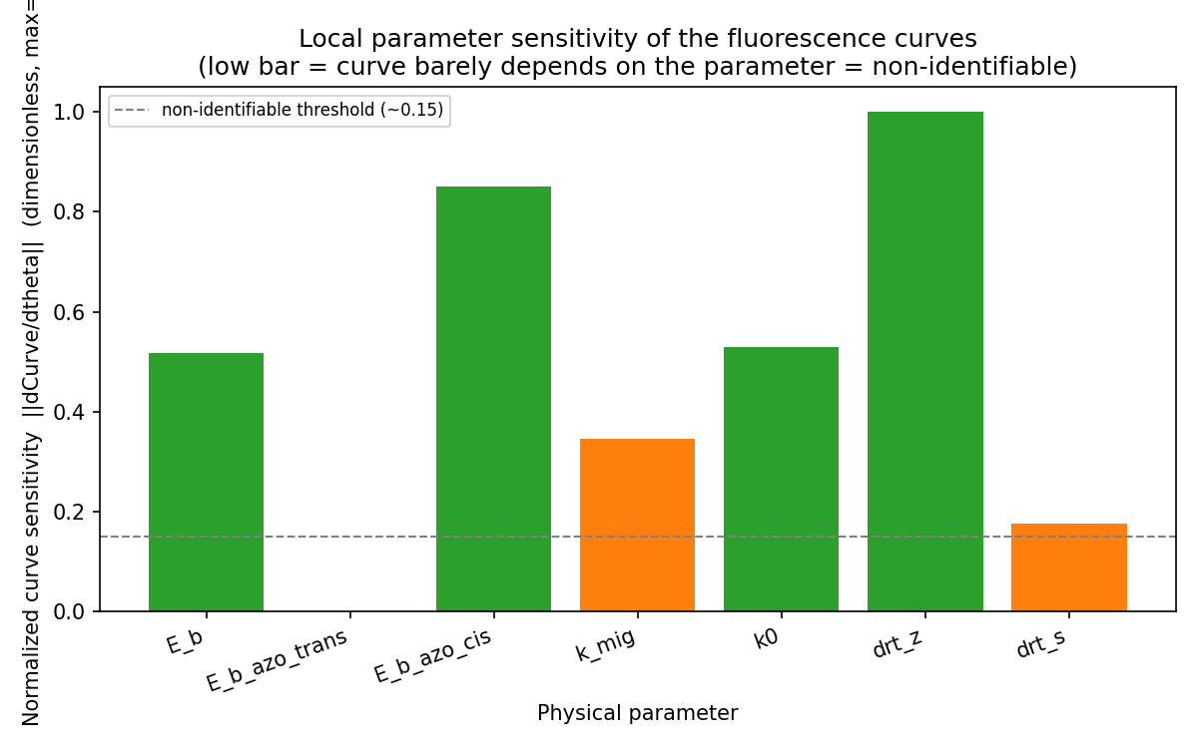
Figure 9. Local curve sensitivity per parameter (normalized column norm of the Jacobian dCurve/dθ, averaged over reference points). Low bars mark parameters the fluorescence curves barely constrain; the Fisher-information condition number is ≈ 1.3×10¹⁵, indicating a near-singular inverse problem.
Value of the deep-learning warm start. Under an identical physics refiner, four initialization strategies were compared on 50 target curves with cost measured in forward-simulation calls. The CNN warm start reaches the target curve RMSE with a median of 1 call (its prediction already meets the target for most curves), versus 96 for a uniform-random start, 141 for the reference parameters, and 185 for Latin-Hypercube multi-start — a roughly two-orders-of-magnitude reduction in the simulation budget for equal-quality refinement. Latin-Hypercube multi-start reaches a similar final fit only by spending ~3.7× the total simulation cost. This shows the deep-learning prediction is not diluted by refinement; it slashes the physical-simulation cost of reaching a given curve fit (Figure 10).
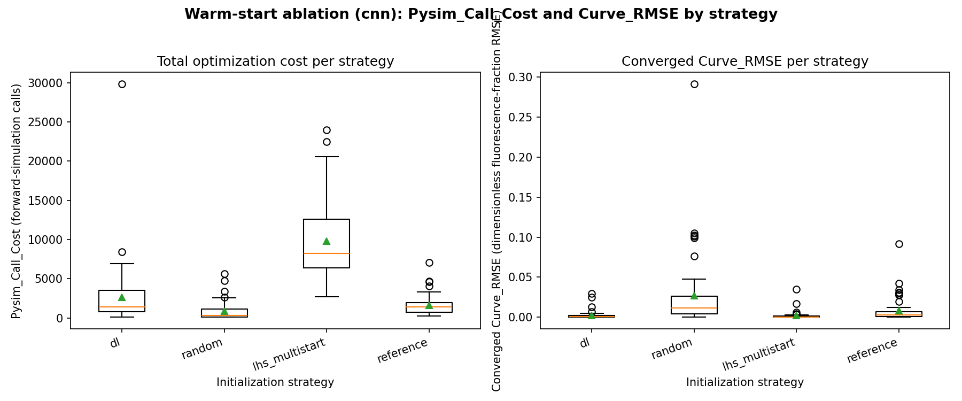
Figure 10. Warm-start ablation over 50 target curves under an identical refiner. Left: total simulation cost (forward-simulation calls) per initialization strategy; right: converged curve RMSE. The CNN warm start reaches the target at a median of 1 forward-simulation call, far fewer than random, reference, or Latin-Hypercube multi-start initializations.
Statistical robustness of the model ranking. Retraining each architecture from scratch with five seeds and evaluating on the same fixed held-out test set gives CNN 0.0196±0.0007 (coefficient of variation 3.5%) versus Transformer 0.0395±0.0036 (9.1%). The two ranges do not overlap — the CNN's worst seed still clearly beats the Transformer's best — so the CNN advantage is a structural property of this task rather than a single-run artifact (Figure 11).
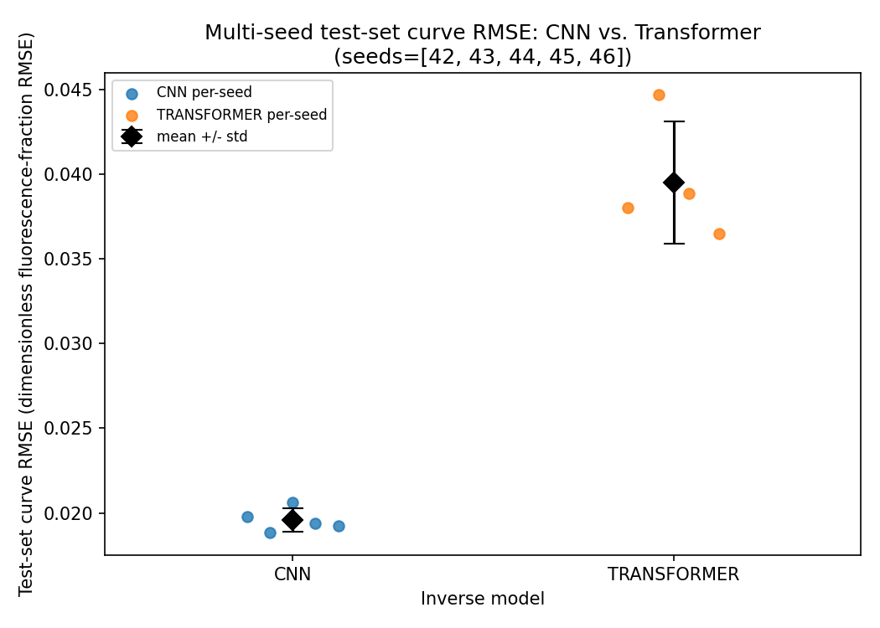
Figure 11. Multi-seed test-set curve RMSE for CNN (5 seeds) and Transformer (4 seeds), each retrained from scratch and evaluated on the same fixed held-out split. Markers show per-seed values; diamonds show mean ± sample standard deviation. The non-overlapping ranges indicate a statistically robust CNN advantage.

4f. Why the CNN outperforms the Transformer
The preceding evaluations converge on a consistent, multi-pronged explanation for the CNN's advantage. We summarize the evidence and then the mechanism.
(1) Accuracy across every channel. On the 1,000-sample held-out test set the CNN has a lower curve-reconstruction RMSE in all three channels (FAM 0.0166 vs. 0.0423, TYE 0.0234 vs. 0.0625, CY5 0.0165 vs. 0.0346), not just on average (Table 3). The advantage is therefore uniform, not the result of trading one channel for another.
(2) Reliability / catastrophic failures. The decisive practical difference is robustness: 999/1000 CNN predictions yield valid, physical simulations (1 invalid, 0 extreme), whereas the Transformer produces 23 invalid and 9 extreme predictions (968/1000 valid). A 3.2% catastrophic-failure rate versus 0.1% matters for a closed-loop design tool, where a single non-physical parameter set wastes an expensive simulation. This also drives the heavier right tail of the Transformer error distribution (P90 0.117 vs. 0.047).
(3) Statistical robustness. The five-seed retraining study (Figure 11) shows the gap is structural, not a lucky initialization: CNN 0.0196±0.0007 (CV 3.5%) vs. Transformer 0.0395±0.0036 (CV 9.1%), with non-overlapping ranges. The CNN is both more accurate and more stable seed-to-seed.
(4) It is the inductive bias, not the capacity. A natural objection is that the CNN simply has more parameters (4.38M vs. 3.24M). Two capacity-control ablations refute this. Shrinking the CNN to the Transformer's capacity (4.38M → 3.27M) leaves it essentially unchanged (RMSE 0.0188 → 0.0190), still far ahead; conversely, enlarging the Transformer to the CNN's capacity (3.24M → 4.30M, 4 → 6 layers) does not help (0.0465 → 0.0476). The CNN advantage therefore comes from its architectural bias being matched to the signal, not from raw parameter count (Table 4).
Mechanistically, the diagnostic information in these curves is local, smooth, and low-frequency, which is exactly the regime a convolutional hierarchy is built for. Three data-backed observations make this concrete and are summarized in Figures 12 and 13. First, a power-spectrum analysis shows that ~95% of each curve's energy lies below ~0.003 Hz — only one to two oscillations per 10-minute window — so there is no high-frequency, token-level structure for attention to exploit. Second, stacking the four convolutional blocks gives each output neuron a receptive field of ~399 s (≈6.7 min), already spanning the core 10-minute light-switching cycle while covering only ~5% of the sequence, so global context is unnecessary. Third, the signals decorrelate on a ~20-minute scale, comparable to the CNN's receptive field, so the long-range dependency the Transformer could exploit is limited. Global self-attention is therefore redundant capacity here, and being more data-hungry it yields both higher error and a higher catastrophic-failure rate on the ~24,000 training samples. The broader lesson is that matching the architecture's inductive bias to the task structure matters more than model complexity.
Table 3. Per-channel curve-reconstruction RMSE on the 1,000-sample held-out test set (pre-refinement), with valid-prediction rate. The CNN is lower in every channel and far more reliable.
Channel / metric | 1D-CNN | Transformer
FAM RMSE | 0.0166 | 0.0423
TYE RMSE | 0.0234 | 0.0625
CY5 RMSE | 0.0165 | 0.0346
Valid-prediction rate | 999/1000 (99.9%) | 968/1000 (96.8%)
Table 4. Capacity-control ablation. Matching parameter counts across architectures does not close the gap, showing the CNN advantage is due to inductive bias rather than capacity.
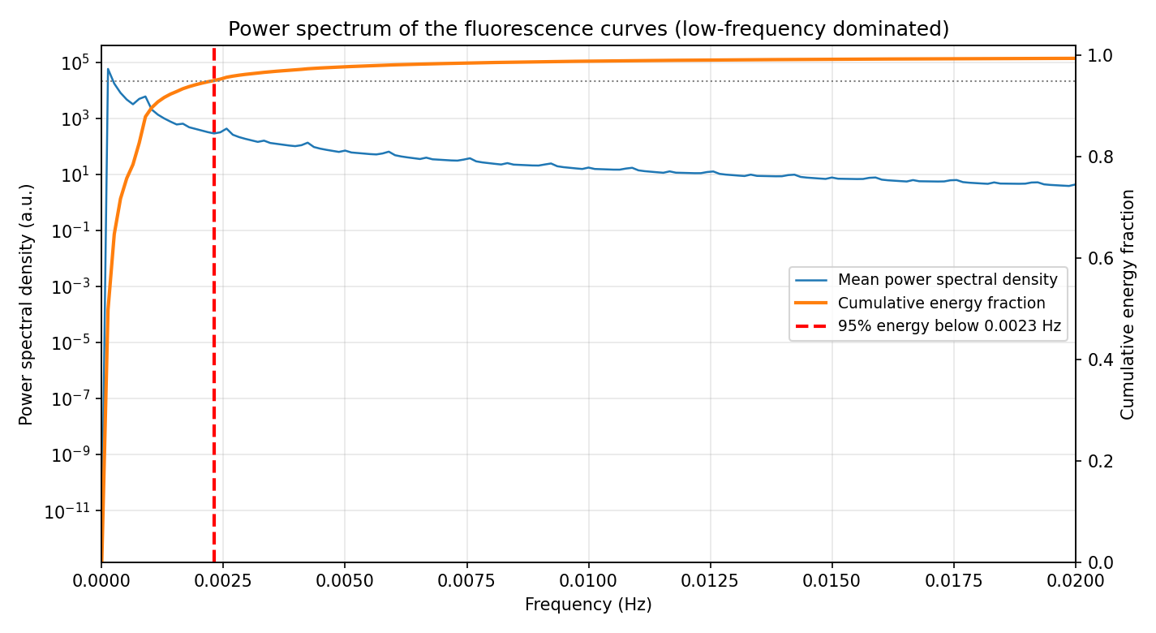
Figure 12. Power spectrum of the fluorescence curves. About 95% of the signal energy lies below ~0.003 Hz (1–2 oscillations per 10-minute window), showing the task is dominated by low-frequency, smooth structure with no high-frequency content for token-level attention to model.
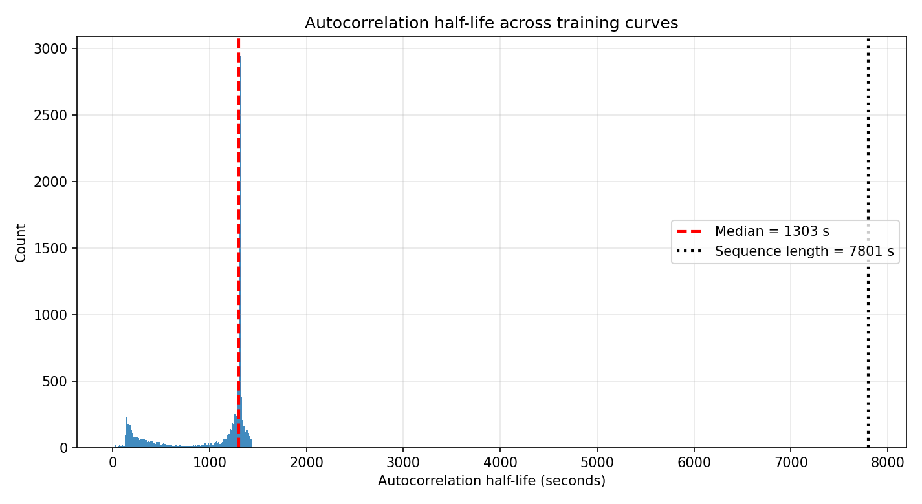
Figure 13. Signal autocorrelation. The curves decorrelate on a ~20-minute scale, comparable to the CNN's ~6.7-minute stacked receptive field, indicating that the long-range dependencies a global-attention model could exploit are limited for this system.
Configuration | Parameters | RMSE mean | RMSE median | Valid rate
CNN (standard) | 4.38M | 0.0188 | 0.0096 | 99.9%
CNN shrunk to Transformer capacity | 3.27M | 0.0190 | 0.0102 | 99.9%
Transformer (standard) | 3.24M | 0.0465 | 0.0153 | 96.8%
Transformer enlarged to CNN capacity | 4.30M | 0.0476 | 0.0158 | 99.4%

5. Insights and Discussion

5a. Interpreting the Observed Model Behavior
The evaluation shows that the learned inverse map captures structure in the simulator-generated mapping that remains useful on the experimental traces after physics refinement. The synthetic recovery experiment clarifies why a refinement step is necessary: only the kinetic/duty-ratio parameters (drt_z, k0, drt_s) are even moderately recoverable from the curves (R² ≈ 0.42–0.55), while the binding energies and migration rate are poorly constrained. Small median relative errors coexisting with low or negative R² indicate predictions that cluster near the truth without tracking it — the signature of a parameter the curves barely constrain.
The model comparison reverses a naive architectural expectation. Despite its global receptive field and explicit cross-channel attention, the Transformer is less accurate and less stable than the CNN on this task, with a substantially higher catastrophic-failure rate (3.2% vs. 0.1% on the test set). A plausible reason is that the fluorescence curves are smooth and dominated by the 10-minute illumination cycle, a regime where the CNN's larger effective capacity and local-to-global convolutional hierarchy fit the signal more reliably than attention, which appears more prone to occasional non-physical predictions here.

5b. What Can Be Learned from the Current Study
The scientific value of the pipeline is both methodological and quantitative. The deep-learning warm start measurably reduces the physical-simulation cost of refinement (median 1 vs. ~100–185 forward-simulation calls to reach the target), so the framework is not merely 'a neural net plus an optimizer' — the network slashes the simulation budget needed to reach a given curve fit, which is the practically expensive resource.
At the same time, the inferred parameters should not be read as uniquely recovered ground truth. The Fisher-information and profile-likelihood analyses show a near-singular, parameter-dependent identifiability structure, and the study does not yet quantify full posterior uncertainty or solution multiplicity. Closed-loop and curve-space agreement therefore remain the appropriate interpretation, not definitive physical identification of every parameter.

5c. Generalization and Its Limits
The closed-loop results now span two experimental traces (original and generalization), on both of which the predicted-and-refined CNN parameters beat the reference fit (0.0078 vs. ~0.0089 original; 0.0161 vs. ~0.0338 generalization). This is stronger than a single-trace check and provides preliminary evidence of generalization, but it is still not equivalent to demonstrating robust sim-to-real transfer: the simulator omits real-world effects (photobleaching, crosstalk, drift) and only one motor design under a fixed illumination protocol has been tested.
More rigorous claims would require additional experimental traces, perturbation conditions, repeated measurements, and uncertainty-aware inversion. Until then, sim-to-real transfer should continue to be described cautiously even though the two-trace evidence is encouraging.

5d. Future Directions
Several extensions follow naturally. Uncertainty quantification (e.g. via the existing test-time ensemble) would separate confident from weakly constrained predictions and could be calibrated on synthetic data; additional experimental traces would test reproducibility and sim-to-real robustness more broadly; and targeted perturbation experiments could improve the practical identifiability of the currently weakly constrained parameters. With identifiability now quantified and the warm-start value demonstrated, these are the natural next steps toward a fully validated inverse-design platform.

6. Summary
This report studied a seven-parameter inverse problem for a light-driven DNA molecular motor using three-channel fluorescence kinetics as the observable input. A finite-state mechanical-kinetic simulator — re-implemented as a bit-aligned, ~35×-faster pure-Python module — generated 30,000 synthetic training samples, and two inverse models were trained on them: a 1D-CNN and a PatchTST-inspired Transformer with multi-head temporal and cross-channel attention. At inference, each prediction is refined in curve space against the original simulator (Powell with multi-start).
The main findings are: (i) on a 1,000-sample held-out test set the CNN is uniformly more accurate and more stable than the Transformer, a gap confirmed as statistically robust by a five-seed study (CNN 0.0196±0.0007 vs. Transformer 0.0395±0.0036, non-overlapping ranges); (ii) the deep-learning warm start reduces the simulation cost of refinement by about two orders of magnitude relative to uninformed initial guesses; and (iii) on two experimental traces the predicted-and-refined CNN parameters regenerate trajectories closer to the measurements than the reference parameter set (0.0078 vs. ~0.0089 original; 0.0161 vs. ~0.0338 generalization).
The study also makes the problem's limits explicit and quantitative. Fisher-information and profile-likelihood analyses show the inverse map is intrinsically ill-posed (condition number ≈ 1.3×10¹⁵) with parameter-dependent identifiability, so the inferred parameters are best interpreted as closed-loop-consistent candidates rather than uniquely recovered ground truth, and the experimental validation — though extended to a generalization trace — remains limited in scope. The work is therefore best framed as a validated workflow for deep-learning-assisted, physics-refined closed-loop inverse characterization, with broad sim-to-real validation and uncertainty quantification as the principal remaining steps.

References
- Carbone, A., Seeman, N.C. (2003). Molecular Tiling and DNA Self-assembly. In: Jonoska, N., Păun, G., Rozenberg, G. (eds) Aspects of Molecular Computing. Lecture Notes in Computer Science, vol 2950. Springer, Berlin, Heidelberg. https://doi.org/10.1007/978-3-540-24635-0_5
- Kamiya, Y., & Asanuma, H. (2014). Light-Driven DNA Nanomachine with a Photoresponsive Molecular Engine. Accounts of Chemical Research, 47(6), 1663-1672. https://doi.org/10.1021/ar400308f
- Madhanagopal, B.R., Wang, T. & Chandrasekaran, A.R. Light-responsive DNA nanostructures. Nat Rev Chem (2026). https://doi.org/10.1038/s41570-026-00817-8
- Gu, J., Laszik, N., Miles, C.E., Allard, J., Downing, T.L., Read, E.L. (2025). Scalable inference and identifiability of kinetic parameters for transcriptional bursting from single cell data. Bioinformatics, 41(11), btaf581. https://doi.org/10.1093/bioinformatics/btaf581
- Padarian, J., Minasny, B., McBratney, A.B. (2019). Using deep learning to predict soil properties from regional spectral data. Geoderma Regional, 16, e00198. https://doi.org/10.1016/j.geodrs.2018.e00198
- Jonas, E. (2019). Deep imitation learning for molecular inverse problems. In Advances in Neural Information Processing Systems 32 (NeurIPS 2019). https://papers.nips.cc/paper_files/paper/2019/hash/b0bef4c9a6e50d43880191492d4fc827-Abstract.html
- Yazdani, A., Lu, L., Raissi, M., Karniadakis, G.E. (2020). Systems biology informed deep learning for inferring parameters and hidden dynamics. PLoS Computational Biology, 16(11), e1007575. https://doi.org/10.1371/journal.pcbi.1007575
- Hou, R., Loh, I.Y., Li, H., Wang, Z. (2017). Mechanical-Kinetic Modeling of a Molecular Walker from a Modular Design Principle. Physical Review Applied, 7(2), 024020. https://doi.org/10.1103/PhysRevApplied.7.024020
- LeCun, Y., Bottou, L., Bengio, Y., Haffner, P. (1998). Gradient-based learning applied to document recognition. Proceedings of the IEEE, 86(11), 2278–2324. https://doi.org/10.1109/5.726791
- Kiranyaz, S., Avci, O., Abdeljaber, O., Ince, T., Gabbouj, M., Inman, D.J. (2021). 1D convolutional neural networks and applications: A survey. Mechanical Systems and Signal Processing, 151, 107398. https://doi.org/10.1016/j.ymssp.2020.107398
- Vaswani, A., Shazeer, N., Parmar, N., Uszkoreit, J., Jones, L., Gomez, A.N., Kaiser, Ł., Polosukhin, I. (2017). Attention Is All You Need. In Advances in Neural Information Processing Systems 30 (NeurIPS 2017). https://papers.nips.cc/paper/7181-attention-is-all-you-need
- Nie, Y., Nguyen, N.H., Sinthong, P., Kalagnanam, J. (2023). A Time Series is Worth 64 Words: Long-term Forecasting with Transformers. In The Eleventh International Conference on Learning Representations (ICLR 2023).
- W. Yu et al., "MetaFormer is Actually What You Need for Vision," 2022 IEEE/CVF Conference on Computer Vision and Pattern Recognition (CVPR), New Orleans, LA, USA, 2022, pp. 10809-10819, doi: 10.1109/CVPR52688.2022.01055.

Acknowledgment and Declaration
I would like to express my sincere gratitude to Prof. Wang Zhisong for his supervision and for providing the physics-based simulation model that forms the foundation of this work. I also thank Prof. Duane Loh for his guidance on the machine learning methodology and model design. The computational resources were provided by the National University of Singapore High Performance Computing (NUS HPC) cluster.
AI Tool Declaration:
I used Gemini/Claude AI tools to assist in:
• Debugging and optimizing Python code for model training and data preprocessing
• Improving the structure and expression of the report
• Generating code documentation and comments
I did not use AI tools to generate the scientific reasoning, experimental design, model architecture decisions, results interpretation, or conclusions presented in this report. I am fully responsible for the content, scientific integrity, and quality of the submitted work.

Appendix
Appendix A — Model Architecture Diagrams
The InverseCNN architecture processes input as follows:
Input(3, 7801) → Conv1(32, ~1950) → Pool → Conv2(64, ~487) → Pool → Conv3(128, ~121) → Pool → Conv4(256, ~30) → AdaptiveAvgPool(64) → Flatten → FC(256) → FC(128) → FC(7) → Sigmoid
The DNAWalkerTransformer (PatchTST-inspired, multi-head attention) processes input as follows:
Input(3, 7801) → PatchEmbed(patch=stride=100) → LearnablePosEnc → N× TemporalSelfAttention(MHA)+FFN (per channel) → M× CrossChannelAttention(MHA)+FFN → GlobalAvgPool(patch) → GlobalAvgPool(channel) → LayerNorm → FC(d_model/2) → GELU → FC(7) → Sigmoid
Inference (both models): curves → model → 7 parameters → physics refinement (Powell + multi-start, curve-RMSE objective via pysim) → final physical parameters.
Appendix B — Physical Parameters and Ranges
Parameter | Physical Meaning | Range | Unit | Transform
E_b | Base-pair binding energy | [−2.0, −0.5] | k_BT | None
E_b_azo_trans | Trans-azo hairpin binding | [−2.0, −0.5] | k_BT | None
E_b_azo_cis | Cis-azo hairpin binding | [−0.5, 0.2] | k_BT | None
k_mig | Branch migration rate | [0.01, 0.30] | s⁻¹ | None
k₀ | Zero-force detachment rate | [10⁻⁷, 10⁻⁴] | s⁻¹ | log10
drt_z | Unzipping coupling distance | [0.20, 0.90] | nm | None
drt_s | Shearing coupling distance | [0.01, 0.50] | nm | None

Appendix C — Code Availability
The complete source code for this project is organized as follows:
Root directory (shared pure-Python physics core):
• pysim.py — 14-state Markov forward simulator (bit-aligned Python port of gendata.m, ~35× faster)
• gendata.py — synthetic training-data generation (multiprocessing + LHS binning)
• refine.py — model-agnostic physics refinement (Powell/Nelder-Mead, curve-RMSE objective)
• verify.py — forward verification + RMSE + comparison plots
• exp_data_io.py — robust experimental-Excel loader; config_loader.py — unified config
• configfile.ini — global configuration (parameter ranges, training hyperparameters)
• gendata.m / verify.m — legacy MATLAB scripts (retained for reference)
train_cnn/ — CNN model (self-contained):
• model_cnn.py (InverseCNN) • data_loader.py • train_mlp.py • inference_cnn.py • predict_refine.py • eval_testset.py • eval_dual.py
train_transformer/ — Transformer model (self-contained):
• model_transformer.py (PatchTST + multi-head attention) • dataset.py • train_transformer.py • inference_transformer.py • predict_refine.py • eval_testset.py
Validation suite (root):
• validate_recovery.py — synthetic parameter-recovery experiment
• analyze_identifiability.py — Jacobian / Fisher-information / profile-likelihood analysis
• benchmark_initguess.py — warm-start vs. baseline initialization ablation
• multiseed_retrain.py — multi-seed retraining + statistical comparison
• validation_common.py — shared helpers; tests/ — property-based + integration testsMechineLearning_for_DNAwalker

